Assignment 3 (7%)

Total :60 marks.

Please work in **groups** of max 3 and min 2 to complete this Assignment. This Assignment is worth 7% of the total course grade and will be evaluated through your written submission, as well as the Assignment demo in the class worth 3%. During the Assignment demo, group members are randomly selected to present the answers to each of the lab questions. Group members not present during the Assignment demo will lose the demo mark. Individual submission will have penalty of 10%.

1. Add this declaration on the top of your file.

We, ------------(mention your names), declare that the attached assignment is our own work in accordance with the Seneca Academic Policy. No part of this assignment has been copied manually or electronically from any other source (including web sites) **or distributed to other students.**

1. Specify what each member has done towards the completion of this work:

Solve the following using tables provided for labs like employees, departments, etc. Copy the commands under each question and also the screen shots of the result. For instance, if you create a view the result will be view is created. Take the screen shot and copy under the command. One member in the group upload the document on BlackBoard.

1. Display department number, department name, and the number of employees working in each department that has the highest number of employees. Use subquery only. (5 marks)

Answer:

select d.department_id, d.department_name, count(e.employee_id) "count"

from employees e, departments d

where e.department_id = d.department_id

group by d.department_id, d.department_name

having count(e.employee_id) = (

select MAX(count(employee_id))

from employees

group by department_id);



1. Display all the employees who were hired on the day of the week on which the highest number of employees were hired. List the first name and last name columns together with a space in between. Label the column as Full Name and label day as day of the week. Use subquery only. (5 marks)

Answer:

SELECT last_name || ' ' || first_name "Full Name", TO_CHAR(hire_date, 'DAY') "day of the week"

FROM employees

WHERE TO_CHAR(hire_date, 'Day') =

(SELECT TO_CHAR(hire_date, 'Day')

FROM employees

GROUP BY TO_CHAR(hire_date, 'Day')

HAVING COUNT(*) = (SELECT MAX(COUNT(*))

FROM employees

GROUP BY TO_CHAR(hire_date, 'Day')));

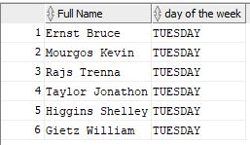

1. Department 50 needs access to its employee data. Create a view named DEPT50 that contains the employee numbers, employee last names, and department numbers for all employees in department 50. They have requested that you label the view columns EMPNO, EMPLOYEE, and DEPTNO. For security purposes, do not allow an employee to be reassigned to another department through the view. (5 marks)

Answer:

CREATE OR REPlACE VIEW DEPT50

AS SELECT employee_id EMPNO, last_name EMPLOYEE, department_id DEPTNO

FROM employees

WHERE department_id = 50

WITH CHECK OPTION CONSTRAINT dept50_ck ;

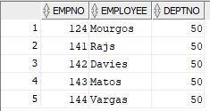

1. Create a view named emp_hired that has the names and hire dates for all employees who were hired before their managers, along with their manager’s names and hire dates. Label the columns Employee, Emp Hired, Manager, and Mgr Hired, respectively.(5 marks)

Answer:

CREATE VIEW emp_hired AS

(

SELECT e.first_name || ' ' || e.last_name "Employee", e.hire_date "Emp Hired",

m.first_name || ' ' || m.last_name "Manager", m.hire_date "Mrg Hired"

FROM employees e LEFT JOIN employees m

ON e.manager_id = m.employee_id

WHERE m.employee_id IS NOT NULL AND e.hire_date < m.hire_date

);

select * from Emp_hired;

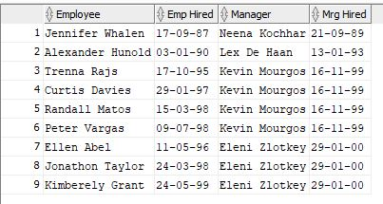

1. The Date base Administrator needs you to create a table, which has a primary key constraint, but she wants to name the index to have a different name than the constraint. Create the Locations_Index table based on the following table instance chart. Name the index for the PRIMARY KEY column as LOCATIONS_PK_IDX. (5 marks)

|  |  |  |
| --- | --- | --- |
| Column Name | Deptno | Dname |
| Primary key | Yes |  |
| Data Type | Number | VARCHAR2 |
| Length | 4 | 30 |

Answer:

CREATE TABLE Department (

Deptno NUMBER(4) CONSTRAINT LOCATIONS_PK_IDX PRIMARY KEY,

Dname varchar(30)

);

1. Create a report of a list of employees who are up for review in March; so you are requested to do the following: (5 marks)

Write a query to display the last names, month of the date of hire, and hire date of those employees who have been hired in the month of March, irrespective of the year of hire.

Answer:

SELECT last_name "last name", TO_CHAR(hire_date, 'MONTH') "Month", hire_date "hire date"

FROM employees

WHERE TO_CHAR(hire_date, 'FMMONTH') = 'MARCH';

a2.JPG

1. The Accounting department requires an analysis on maximum and minimum salaries by job, manager, and department. They have asked you to do the following: (5 marks)

Write a query to display the following groupings:

Department_id, job_id

Job_id, manager_id

Answer:

SELECT job_id, manager_id, department_id, max(salary), min(salary)

FROM employees

GROUP BY GROUPING SETS((department_id, job_id), (job_id, manager_id));

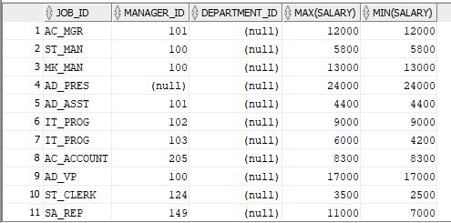

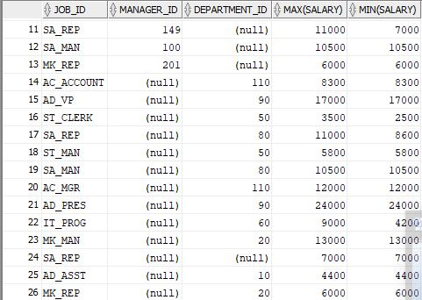

1. Create the EMP table based on the structure of the EMPLOYEES table. Include only the EMPLOYEE_ID, FIRST_NAME, LAST_NAME, SALARY, and JOB_ID columns for departments 90,80,60, and 50. Name the columns in your new table NO, FIRST_NAME, LAST_NAME, SALARY, and JOB_TITLE, respectively. (5 marks)

Answer:

CREATE TABLE EMP("NO", "FIRST_NAME", "LAST_NAME", "SALARY", "JOB_TITLE") AS

(SELECT employee_id, first_name, last_name, salary, job_id

FROM employees

WHERE department_id IN (90, 80, 60, 50));

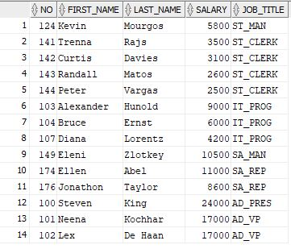

1. (15 marks)

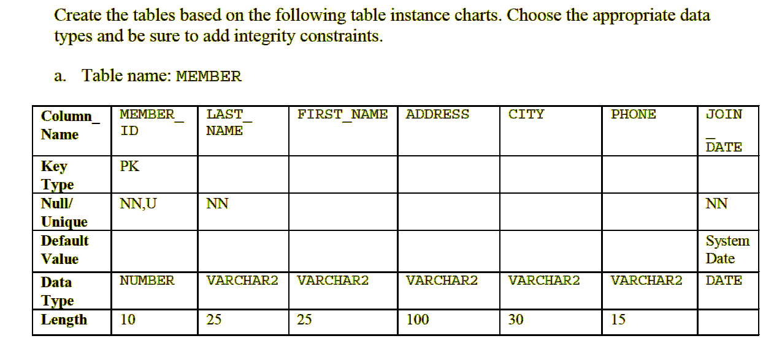

CREATE TABLE MEMBER (

member_id NUMBER(10) NOT NULL ,

last_name varchar2(25) NOT NULL,

first_name varchar2(25),

address varchar2(100),

city varchar2(30),

phone varchar2(15),

join_date Date DEFAULT SYSDATE NOT NULL,

CONSTRAINT member_id_pk PRIMARY KEY(member_id)

);

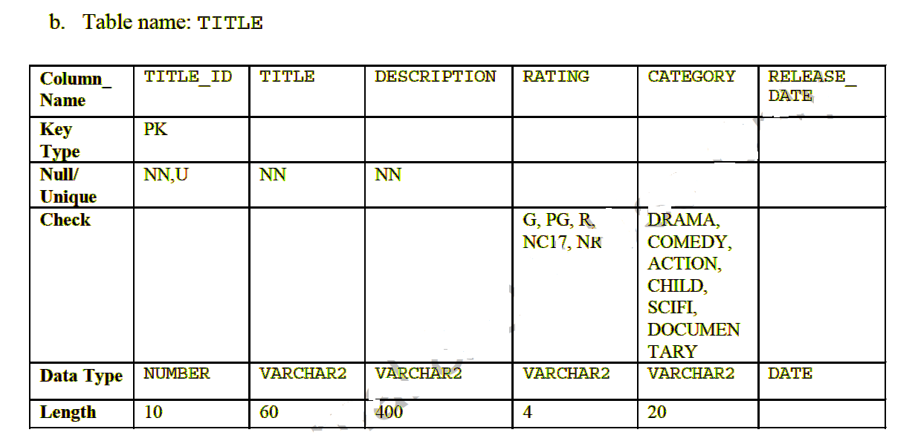

CREATE TABLE TITLE (

title_id NUMBER(10) NOT NULL ,

"title" varchar2(60) NOT NULL,

description varchar2(400) NOT NULL,

rating varchar2(4),

category varchar2(20),

release_date Date,

CHECK (rating IN ('G', 'PG', 'R', 'NC17', 'NR') AND

category IN ('DRAMA', 'COMEDY', 'ACTION', 'CHILD', 'SCIFI', 'DOCUMENTARY')),

CONSTRAINT title_id_pk PRIMARY KEY (title_id)

);

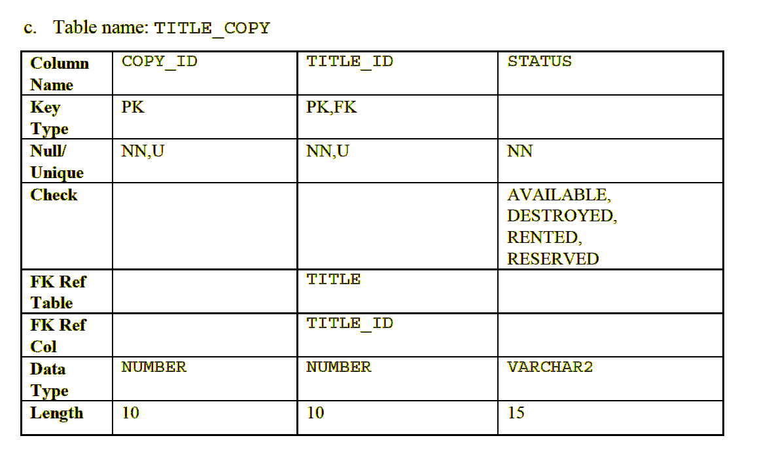

CREATE TABLE TITLE_COPY (

copy_id NUMBER(10) NOT NULL ,

title_id NUMBER(10) NOT NULL,

status varchar2(15) NOT NULL,

CHECK (status IN ('AVAILABLE', 'DESTROYED', 'RENTED', 'RESERVED')),

CONSTRAINT title_copy_pk PRIMARY KEY (copy_id, title_id),

CONSTRAINT title_id_fk FOREIGN KEY (title_id) REFERENCES Title(title_id)

);

1. (5 marks)

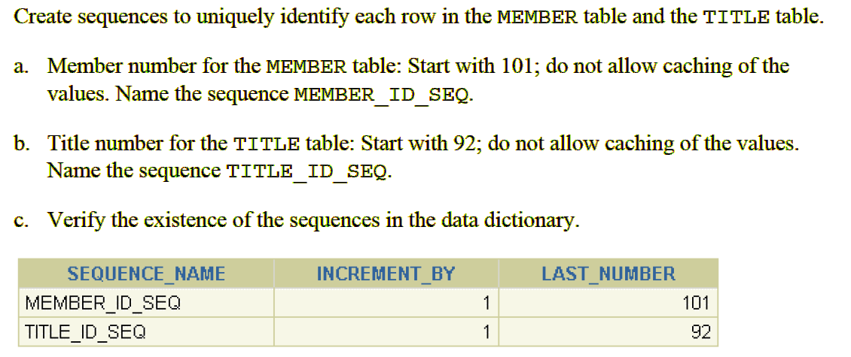

Answers

a.

CREATE SEQUENCE member_id_seq

INCREMENT BY 1

START WITH 101

NOCACHE

NOCYCLE;

b.

CREATE SEQUENCE title_id_seq

INCREMENT BY 1

START WITH 92

NOCACHE

NOCYCLE;

c.

SELECT sequence_name, increment_by, last_number FROM user_sequences;

a4.JPG